1. Chances are your ship is not currently in view lets go ahead and reset the Spaceships coordinates. so here’s a tip click on the **Scene** tab and place your view somewhere where you want the camera to be. For example I moved mine in between the valley.

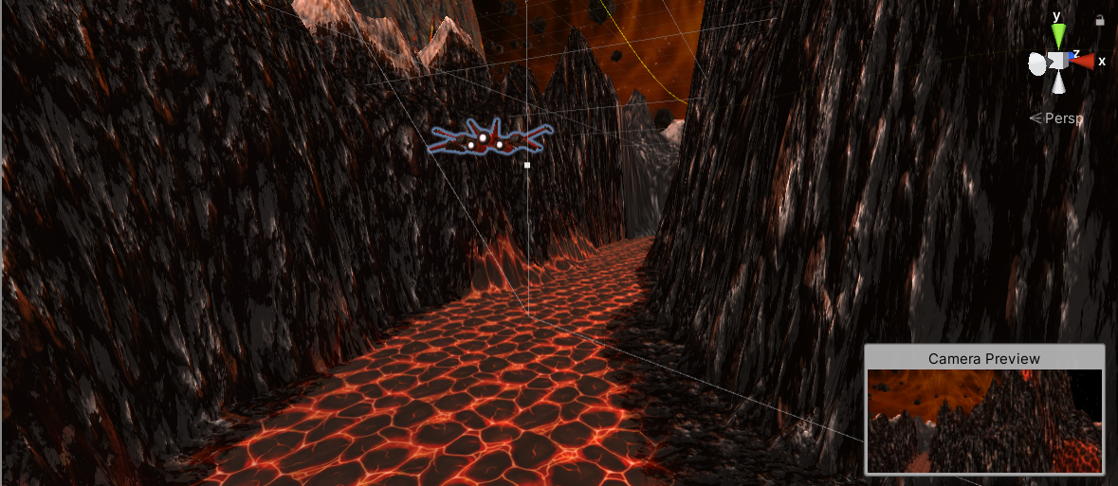

1. Click on **GameObject** in the menu and select **Align With View**. Your ship should appear directly in front of the camera. Now you can adjust the ships position and place it an appropriate distance from the camera.

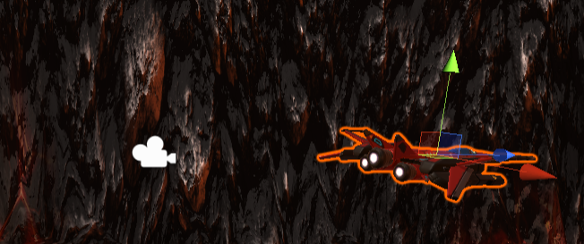

My final view was this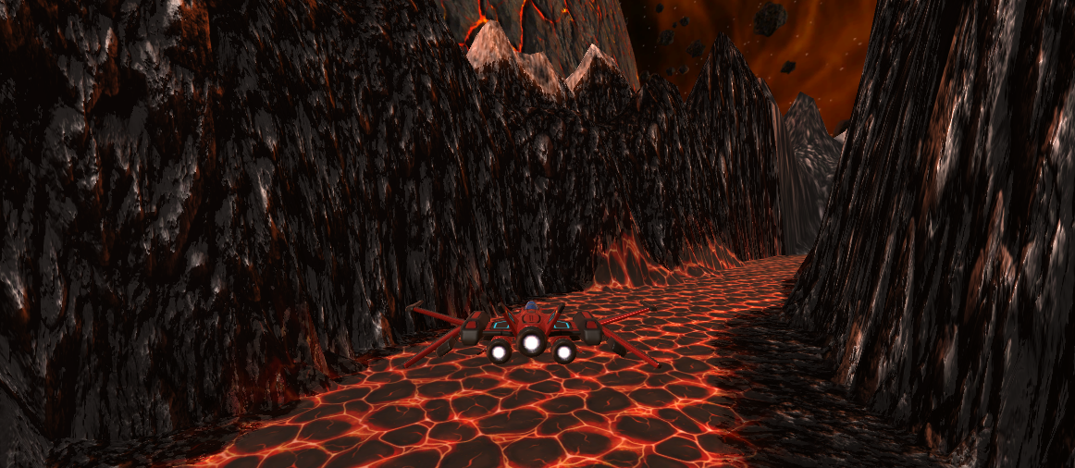

1. Create **Empty GameObject** and call it **Player Rig**
2. Copy the Main Cameras coordinates over to the Player Rig
3. Move the **Main Camera** and the **Player ship** under the **Player Rig**
4. Click on **Window> Sequencing > Timeline**

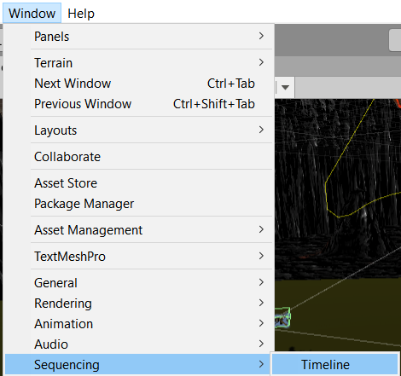

1. Lets move **Timeline** down next to your Console
2. Click on **Window > Animation > Animation** and place it next to Timeline
3. Create **Empty Gameobject** and name it **Master Timeline**.

So this point you might be saying what is actually timeline. Timeline is a tool that allows us to animate things within our game. For example, cut scenes or cinematic sequences. We can animate enemies moving within our world. We can animate things to fall or move in our world. As we're moving around in our world, we can trigger timeline events to happen.

1. Click on **Master Timeline** then in your **Timeline** window click the **Create** button
2. Create new folder in call it **Timeline**
3. Make the name is **Master Timeline** with only ONE Timeline and click **Save**
4. Set timeline to Seconds by click on the gear on the right

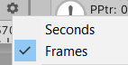

1. Click on the **lock** Icon above that gear icon too.
2. Click on the **Plus > Animation Track**

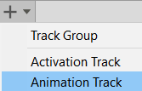

1. Drag **Player Rig** to the new Animation Track field then Select **Create Animator on Player Rig**

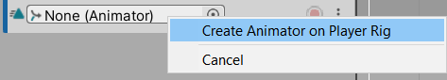

1. Click on the Record button



1. Grab your **Player Rig** and jiggle it up and down to create a **Key Frame** denoted by the grey diamond. That's saying we are recognizing this particular spot in space.
2. Move **Slider** to **1 second** mark and lift your **Player Rig** a bit to denote liftoff. Now it doesn’t matter if you don’t get it right initially. The only thing it records is its final spot.
3. Move timeline to **3 seconds** move your scene to where you want your ship to move to. Select **Player Rig** then go to **GameObject> Align with view**. This should have moved everything to where you were looking at and create a Key Frame.
4. Now if you move your slider you should be able to see your Player Ships current path
5. Click on Edit > Preferences > Colors and look for Grid. Change this color to something that pops.

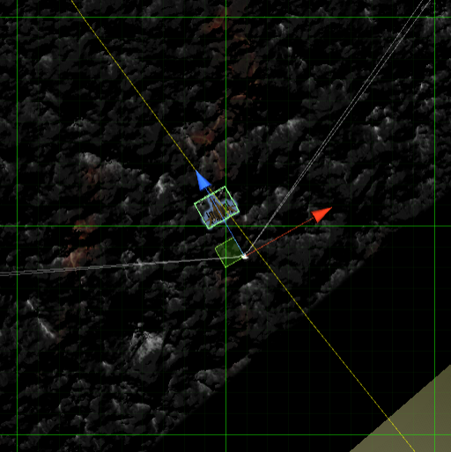

1. Now it takes about 2 seconds to cross a square.
2. Move the slider to 5 seconds and move your Player Rig a grid.
3. Turn **OFF record**. Move the **Slider to 0** and **press Play**.

Create about 30 seconds of gameplay.

Possible Bug:

if you want you ship to make a loop but its turning the wrong direction then that means your rotation y is higher/lower

Click on the graph then on Rotation.y

look for a steep slope and adjust it there.

